**GitHub Repo** : <https://github.com/cheekuag/ImageProcessing>

**Collaborators:**

1. Ayushya Anand
2. Rahul Parihar
3. Amit Kumar
4. Abhinav Bollam
5. Pardhu Chowdary Bangarambandi

**To run the program:**

**Info to remember :**

“**java-server**” is linked to “**Js Puppeteer**” from “ImageProcessing/JavaServer/src/main/java/com/Sprinklr/server/controller/**ServiceToJs.java**”

Using “**Js Puppeteer**” container name as “**Js-container** ”

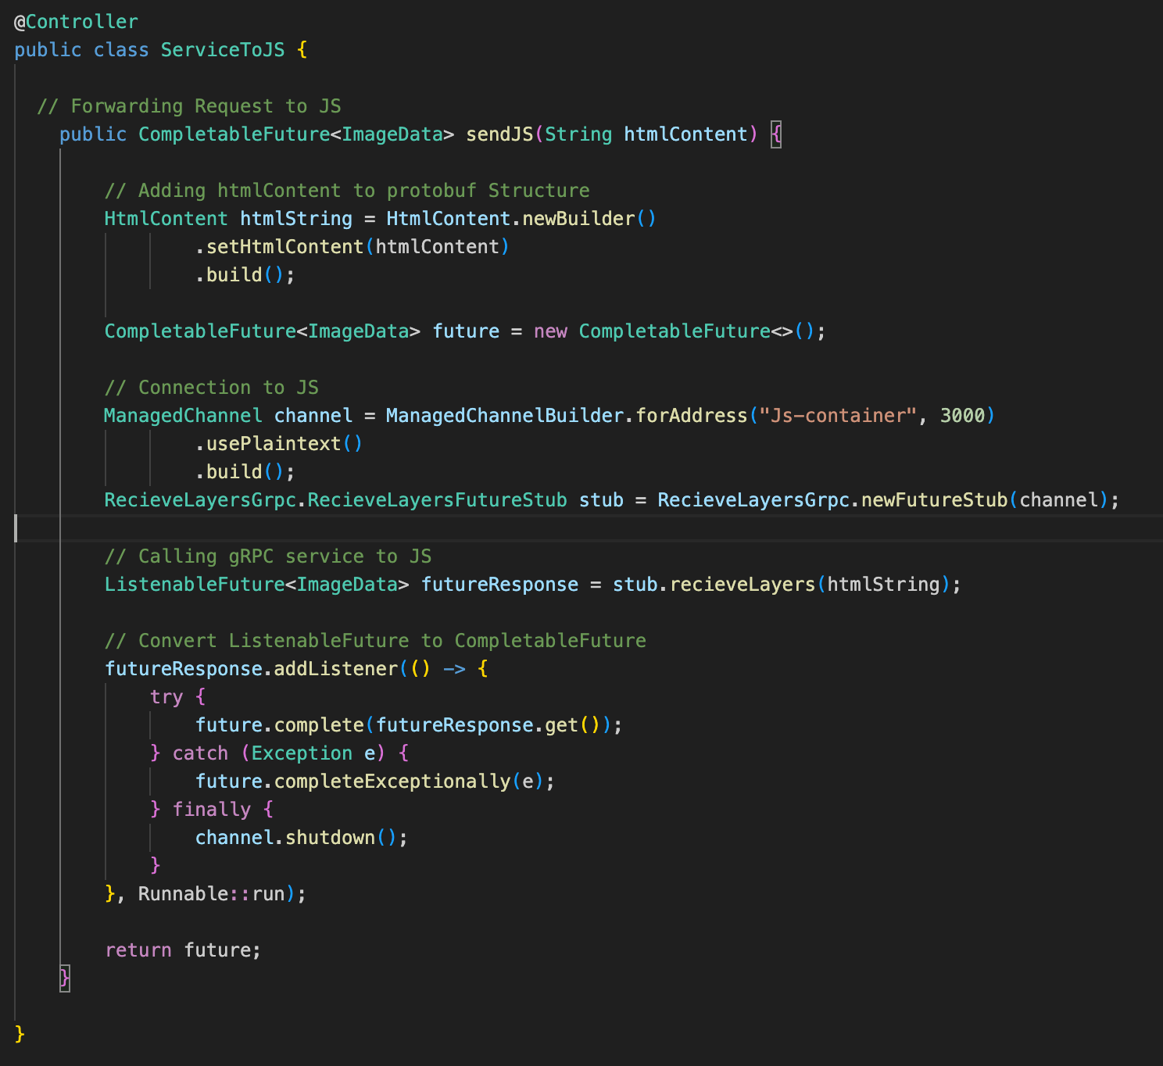

So please follow exact same steps to get Docker running

1. **In Docker**

The current repo code is designed so that they both run on docker, follow the steps to run them.

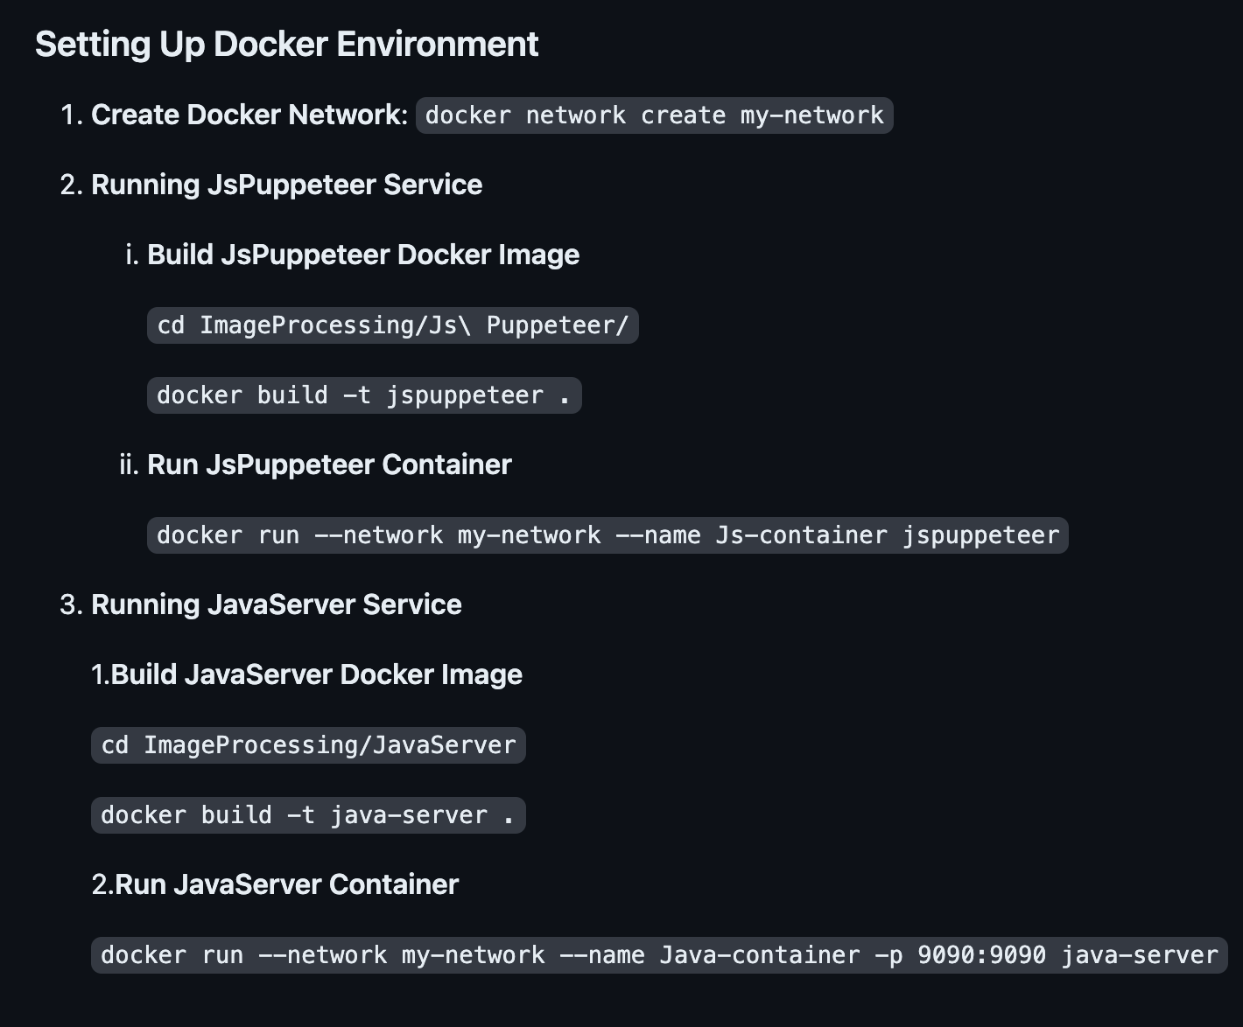

1. Without Docker   
   Just change the “Js-container” with the corresponding IP Address of “Js Puppeteer”.



After making above changes run,

